

# Introduction to Fourier Transform Infrared Spectroscopy (FTIR)

FTIR measures infrared absorption and emission to identify chemical bonds.

This non-destructive technique is vital in materials science, chemistry, and pharmaceuticals.

# Fundamentals and Principles of FTIR

## Infrared absorption



Molecules absorb IR radiation at frequencies matching vibration modes.



## Vibrational frequencies

**Fourier Transform**

Converts raw interferogram data into a readable spectrum.



Specific to molecular bonds, unique fingerprints for

identification.

# Uses and Applications of FTIR

## Material Analysis

* **Polymer characterization**
* **Chemical compound ID**
* **Coating analysis**

## Pharmaceuticals & Food

* **Drug purity checks**
* **Adulteration detection in foods**
* **Environmental pollutant analysis**

**ample Requirements and Applicable Materials**



**Sample Forms**

**Solids, liquids, and gases can be analyzed.**



**Preparation Methods**

**KBr pellets, thin films, ATR technique.**



**Material Types**

**Polymers, organics, inorganics, coatings.**



**Limitations**

**Strong water absorption and particle size effects.**

# FTIR Data Acquisition and Results

## Data Form

Interferogram converted to Absorbance vs. Wavenumber spectrum.

## Peak Analysis

Peaks correspond to molecular vibrations showing chemical groups.

## Preprocessing

Baseline correction and

normalization improve accuracy.



# Data Interpretation and Property Calculation

## Identify Functional Groups



Peak positions reveal groups like C=O or N-H.

## Quantify Concentrations



Peak intensity proportional to compound amount.

## Advanced Analysis



Deconvolution resolves overlapping peaks for clarity.

## Calculations



Crystallinity index from peak ratios in polymers.

# Research Example: Polymer Blend

## Study Insight



1

Peak shifts indicate

polymer miscibility.

## Conclusion



3

**Calculations**

Blending degree estimated using peak area ratios.



2

FTIR confirms molecular interactions in blends.

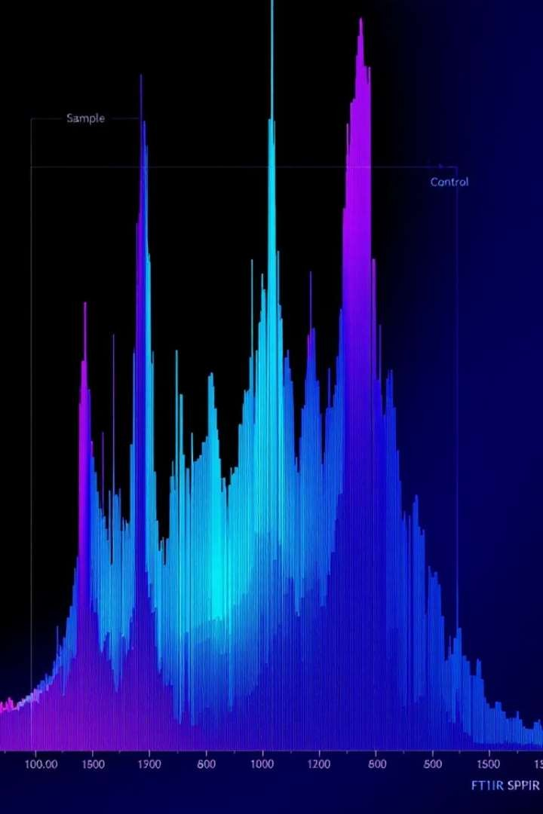

# Summary and Conclusion

## preencoded.pngpreencoded.png Powerful Tool

Essential for diverse material characterization.

## preencoded.png Expansive

**Applications**

Used in polymers, pharmaceuticals, environment, and food.

## preencoded.png Data Interpretation

Requires understanding of vibrational spectra and calculations.

## preencoded.png Advancements

Ongoing improvements enhance accuracy and sensitivity.